EXPERIMENT 1
ROLL NO: 240701181 NAME: HARSHAVARTHINI A

USER INTERFACE AND DESIGN

COMPARISON OF UI DESIGN BETWEEN TWO FIGMA CREATION

BAD DESIGN 👎:

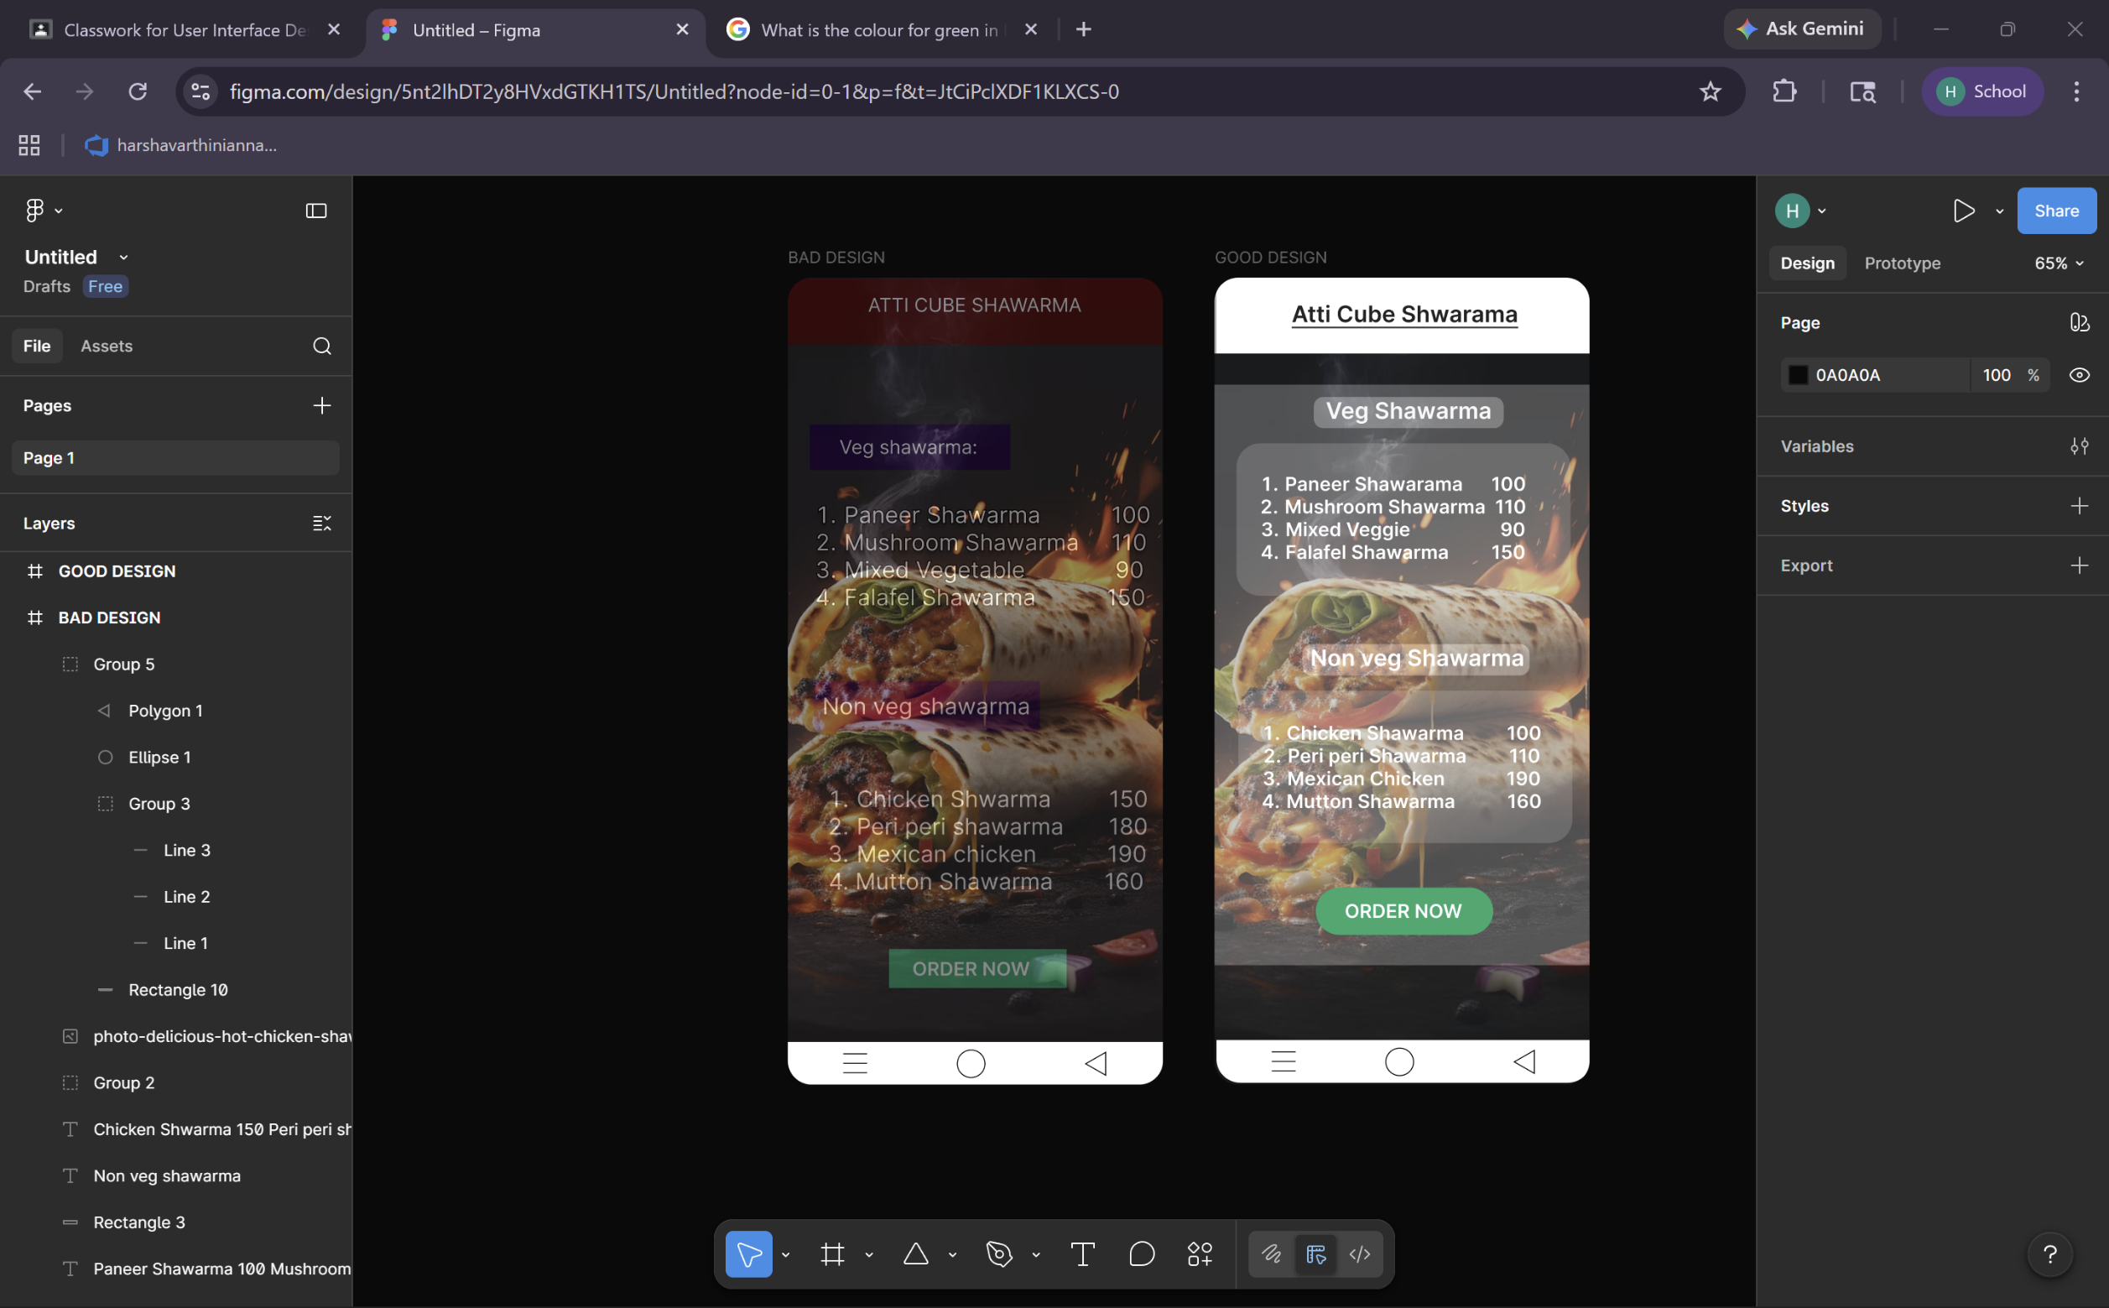

GOOD WEBSITE 👍:

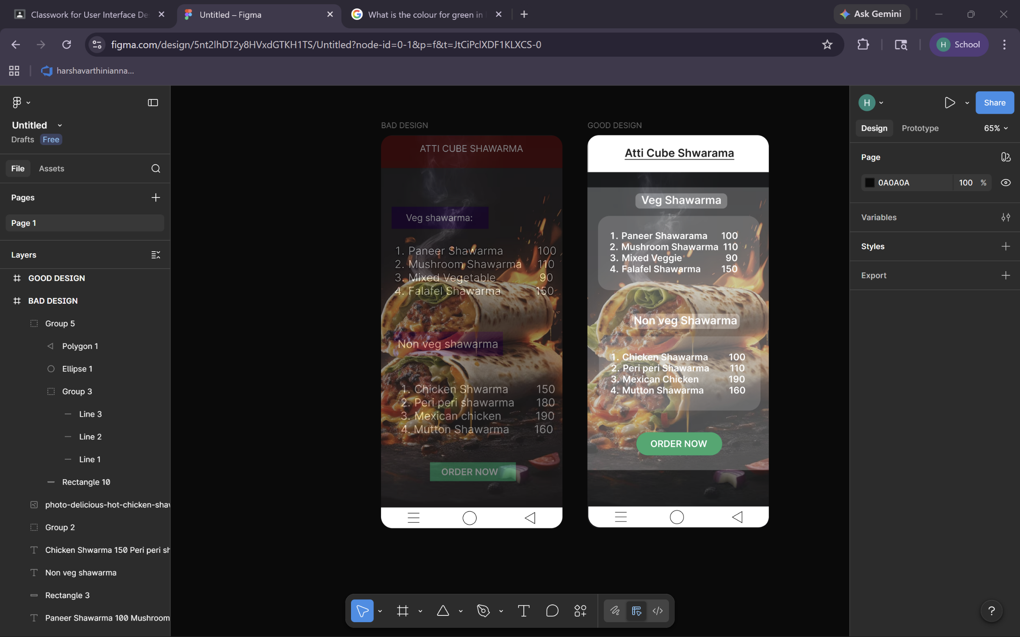

PROTOTYPE LINK:
https://www.figma.com/design/5nt2lhDT2y8HVxdGTKH1TS/Untitled?node-id=0-1&t=JtCiPclXDF1KLXCS-1

The two websites have distinct designs and approaches. Here’s comparison:

BAD DESIGN:

1. Readability
- Text blends with background
- Low contrast
- Hard to read
2. Visual Hierarchy
- No clear focus
- Everything looks same
- Poor section distinction
3. Layout & Alignment
- Misaligned text
- Cluttered layout
- No proper spacing
4. Colors
- Too many colors
- Poor combination
- No consistency
5. User Experience
- Hard to scan
- Confusing structure
- Requires effort
6. Call-to-Action
- Button not visible
- Blends with background
- No emphasis
7. Aesthetics
- Messy look
- Overloaded design
- Unbalanced

GOOD DESIGN:

1. Readability
- High contrast
- Clear text
- Easy to read
2. Visual Hierarchy
- Clear sections
- Proper flow
- Easy navigation
3. Layout & Alignment
- Well aligned
- Clean layout
- Proper spacing
4. Colors
- Limited palette
- Consistent theme
- Purposeful use
5. User Experience
- Easy to scan
- Well structured
- User-friendly
6. Call-to-Action
- Clearly visible
- Highlighted button
- Easy to find
7. Aesthetics
- Clean design
- Balanced layout
- Modern look

KEY DIFFERENCES: BAD vs GOOD Chocolate Website

1. Clarity and Readability
- The bad design lacks clarity due to poor contrast between text and background, making it difficult to read.
- The good design ensures high readability by using proper contrast and clear text separation.

2. Structure and Organization
- The bad design is unstructured, with information appearing scattered and ungrouped.
- The good design presents content in a well-organized and logically structured manner.

3. Visual Hierarchy
- The bad design does not establish a clear visual hierarchy, making it difficult to identify important elements.
- The good design effectively guides user attention through proper hierarchy and emphasis.

4. Layout and Alignment
- The bad design has poor alignment and inadequate spacing, resulting in a cluttered layout.
- The good design uses proper alignment and spacing to create a clean and balanced interface.

5. Use of Colors
- The bad design uses excessive and inconsistent colors, leading to visual confusion.
- The good design follows a limited and consistent color palette, enhancing visual appeal.

6. User Experience (UX)
- The bad design provides a poor user experience due to difficulty in scanning and navigation.
- The good design is user-friendly and allows users to quickly understand and access information.

7. Call-to-Action (CTA) Visibility
- In the bad design, the call-to-action is not prominent and blends with the background.
- In the good design, the call-to-action is clearly highlighted and easily noticeable.

8. Overall Aesthetic Appeal
- The bad design appears cluttered and unprofessional.
- The good design maintains a clean, modern, and visually appealing appearance.

